Log on to the system with your Student-login (and not your student helper-login):
http://timesheet.sdu.dk
You will get a picture like that, so you will always be able to see how far your timesheet is in the system. Also you will be able to see the completed timesheet.
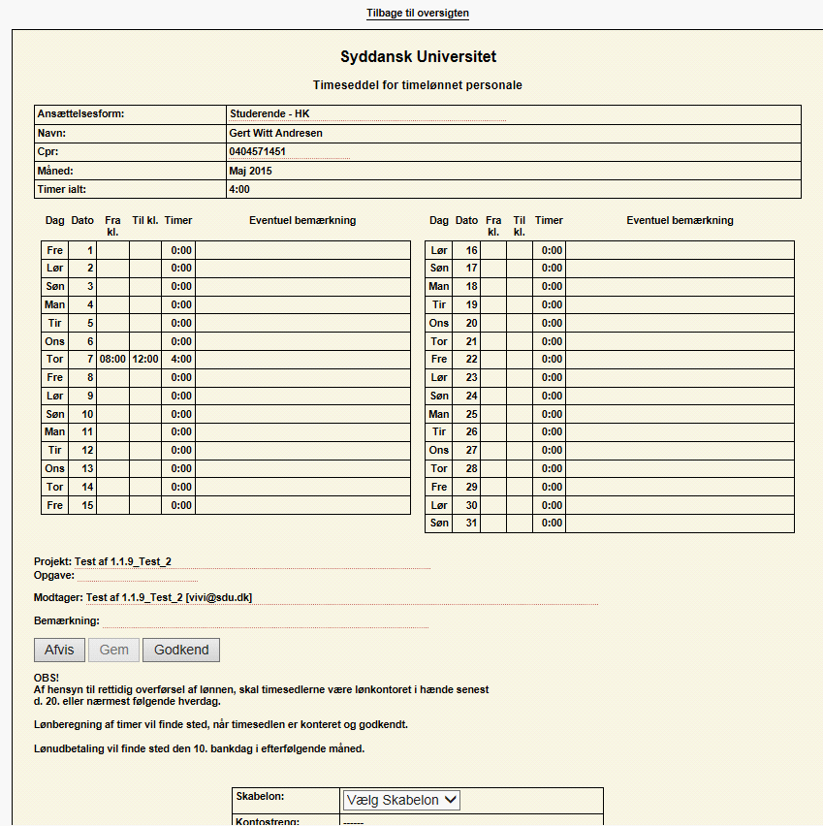

Link to the video:
http://webhotel.sdu.dk/adm/pub/timesheet/How_to_TimeSheet.mp4
It is now only possible to make a timesheet current month and two previous months. So we recommend that you do a timesheet for your working hours each month.
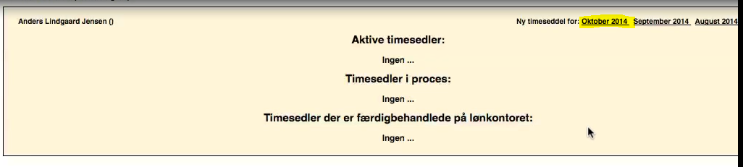
To create a timesheet, click on the month in which you want to create a timesheet, and it takes you to a new timesheet:
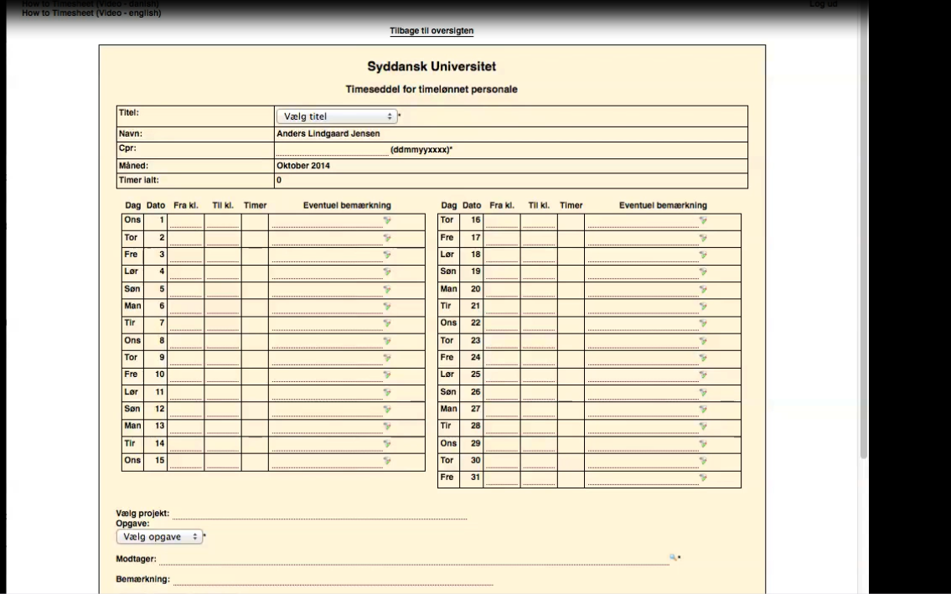

Remember, you must create a timesheet per assignment. That is, if you are employed by two different departments, you must create two timesheets.
If you work on multiple projects, you must also create a timesheet for each project. It is the same procedure as you do now with the ones in paper.
Under ‘Titel’, choose your employment type.
If you don’t know your employment type, you can see it in your employment contract. Otherwise, contact the employee who approves your timesheets at your department.
In this example, I am employed as a student assistant according to ‘HK Collective Agreement’. Therefore I choose this type of employment
Under ‘CPR,’ you enter your social security number. Note that you must enter your number without a hyphen. The system remembers your employment type and social security number, and they will be shown

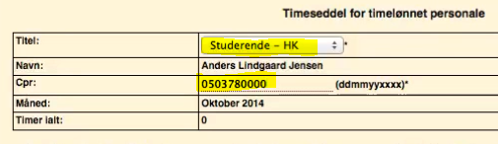

Move on to registration of your working hours.
Click and select from the list the time you started working that day
For example:
- You started Monday at 7:45 and
- You finished at 13:30, so I choose this
- You have the possibility to write state some comments.
  - For example you can write that I worked with Associate Professor Jens
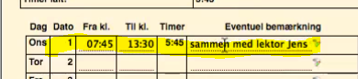

Select the project you are working on or the department in which you are working
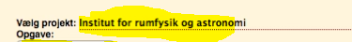

You do not need to write the entire name. You may type a part of it and then select the appropriate project from the list:
If, let’s say, I’m working in the department ‘Institut for rumfysik og astronomi’ – I’ll write ‘astro’
In the list I can see all the projects or departments called something including the letters ‘astro’- now, I can select my department
If you don’t remember your project or task, you should contact the employee who approves your timesheet in your department

The space ‘modtager’ indicates the name of the project / department you selected and the email address(es) of the approver(s)
Here you can write a general remark to your timesheet
For example, I could write that I’m not sure whether I have chosen the right project.

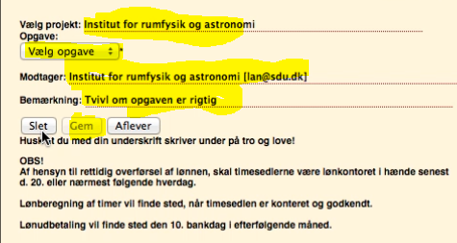

Press the button to save
Once you have saved, the other two buttons are activated and you have the option to:
Delete your entire timesheet and create a new one.
When you have clicked 'GEM', you may log out of the system and return to your timesheet later on.
You can view your saved timesheet on the front page. You can return to it by clicking 'back to the overview'
If you need to access your saved timesheet again, click on your name and your timesheet opens.

Click the button AFLEVER if you don’t have any more working hours this month
Now, the system sends your timesheet to approval.

You can see where your timesheet is in process. It is the same page that you see, when you log into the system. Here you can follow how far your timesheet has come in the process.
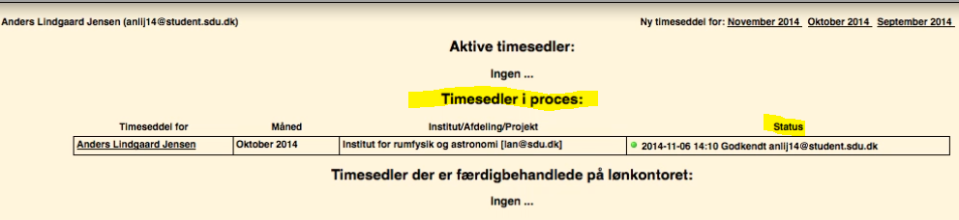

After having clicked the ‘AFLEVER’ button, the system sends you an e-mail containing a link to the system where you can keep track of your timesheet.

You will currently receive status messages when your timesheet proceeds in the process.
You will also receive an e-mail if the Approver rejects your timesheet and returns it to you if something that must be corrected.
Close the browser when you are finished using the system. If you just close the tab, it is possible to enter TimeSheet again without specifying username / password.
When you want to use TimeSheet again, use the URL timesheet.sdu.dk.
You’ll access the system through the university's single-sign-on. Use your SDU username and password
We are now in the system again, and your social security number and employment type are displayed.
If you think you have made an incorrect registration, you can change it or delete it.
Find your timesheet in the overview and click on your name.
Go into the record you want to delete. It is rather tricky - but you can do as follows
Place your mouse pointer on ‘Til kl.’ and click - the drop-down menu appears. Move your mouse pointer outside the menu (the menu collapses). Now, you can delete the time with the ordinary delete keys.
That’s how it’s done.
Repeat the above procedure with your mouse pointer placed on 'Fra kl.’ and save.
As you can see, it’s easy to use TimeSheet.
Thank you for your time.

Bilag 1: Current list, which shows the name of projects, you can use
Godkender - Approver | Betaler - payer
Sonja (for Coen) | Biologi, Coen (AMS) (Bats_FNU)
Rikke Svensson | Biologi, BioTEAM
Sonja (for Coen) | Biologi, Coen (Finker)
Rikke Svensson | Biologi, Rikke (Det Maritime Hus)
Michella | Biologi, Faglig tutor
Thomas Valdemarsen | Biologi, Thomas V og Erik (Gyldensteen)
Henning S. Jensen | Biologi, Henning (Clear)
Sonja (for Jakob) | Biologi, Jakob (Frøer)
Magnus Wahlberg | Biologi, Magnus (hearing in air and under water)
Marianne Holmer | Biologi, MH_fælles(FNU projekt)
Frede Østergaard Andersen | Biologi, MH_Frede (FNU projekt)
Henning S. Jensen | Biologi, MH_Henning (FNU projekt)
Erik Kristensen | Biologi, MH_Erik (FNU projekt)
Marianne Holmer | Biologi, MH_Marianne (FNU projekt)
Mogens Flindt | Biologi, MH_Mogens (FNU projekt)
Kasper Reitzel | Biologi, MH_Kasper (FNU projekt)
Sonja (for Ole) | Biologi, Ole (Parakitter)
Rikke Svensson | Biologi, Rikke (projektdage i Kerteminde)
Peter Stief | Biologi, Peter (Ronnie_sinking aggregates)
Sara Egemose | Biologi, Sara Egemose
Lone Nørgaard Bruun | Biologi, Sekretariatet
Sonja | Biologi, Undervisning
Mette Andersen | Biologi, NordCee_Mette
Bente Frost Holbech | Biologi, Miljøstress_Bente Holbech
Mette Andersen | Biologi, Don Canfield_Mette
Mogens Flindt | Biologi, Mogens Flindt
Sonja (for Ole) | Biologi, Ole (studentermedhjælpstimer)
Frank Bo Jensen | Biologi, Frank Bo (FNU)
Henning S. Jensen | Biologi, Henning (Buffertech)
Dalia Conde | Biologi, Dalia - MaxO
Sonja (for Ole) | Biologi, Ole (studentermedhjælpstimer)
Line Boisen (for Kasper R) | Biologi, RecoverP_Kasper

See annex 1 page 5

