**Guidelines for using the Biology teaching Oasis (Oasen)**

## Responsible persons

Planning

Vanja Bredgaard – [*Vanja@biology.sdu.dk*](mailto:Vanja@biology.sdu.dk), 65502752

Booking

Bente Frost Holbech – [bfj@biology.sdu.dk](mailto:bfj@biology.sdu.dk), 65502735

Technical Coordinator

Peter Søholt – [peter@biology.sdu.dk](mailto:peter@biology.sdu.dk), 65502730

Equipment/organization

Alexander Treusch - [atreusch@biology.sdu.dk](mailto:atreusch@biology.sdu.dk), 65502733

Bente Frost Holbech – [bfj@biology.sdu.dk](mailto:bfj@biology.sdu.dk), 65502735

Safety

Annette Duus – [nette@biology.sdu.dk](mailto:nette@biology.sdu.dk) , 65502750 (Miljøstress)

Dina Holmgaard Skov – dinaskov@biology.sdu.dk, 65508403 (NordCee)

Rikke Orluff Holm – [rikkeh@biology.sdu.dk](mailto:rikkeh@biology.sdu.dk), 65502179 (Øko, Lyd og Adfærd)

IT related installlatios

IT-service/science-IT – helpdesk@sdu.dk,

Technical installations

Technical service - [8888@sdu.dk](mailto:8888@sdu.dk), 65508888

## Table of content

Responsible persons 1

Table of content 2

Overview of the teaching Oasis 3

Oasis map 3

Access to the teaching Oasis 3

Before you start teaching 4

Introducing the students to the teaching facilities and safety in the lab 4

When you finish teaching 5

Practical information 6

Lab coats 6

Waste 6

Water 6

Pipettes 6

Pipette tips 6

Glassware 6

Chemicals and reagents 7

Consumables 7

Trolleys/mobile tables 7

Balances 7

Water baths 7

iPADs 7

Breakage or failure on equipment 8

Suggestions for changes or new/more equipment 8

IT installations 9

Booking screens 9

Info screens 9

Computers in White lab 9

Smart boards 9

Touch screen 9

Technical installations 10

Gas supply 10

Ventilation, fume hoods and punctual suction 11

Cold room temperature 12

Calibration of pipettes 13

## Overview of the teaching Oasis

### Oasis map

The Green and the Yellow labs are both used by Biology whereas the Black lab is shared with Department of BMB. The students primarily enter the teaching Oasis from STENTEN via V5-503-1, where cabinets for bags etc. are located. Please note that entrance to the Blue lab is through V7-503-1, V7-505-1 and the red lab - not the yellow lab.

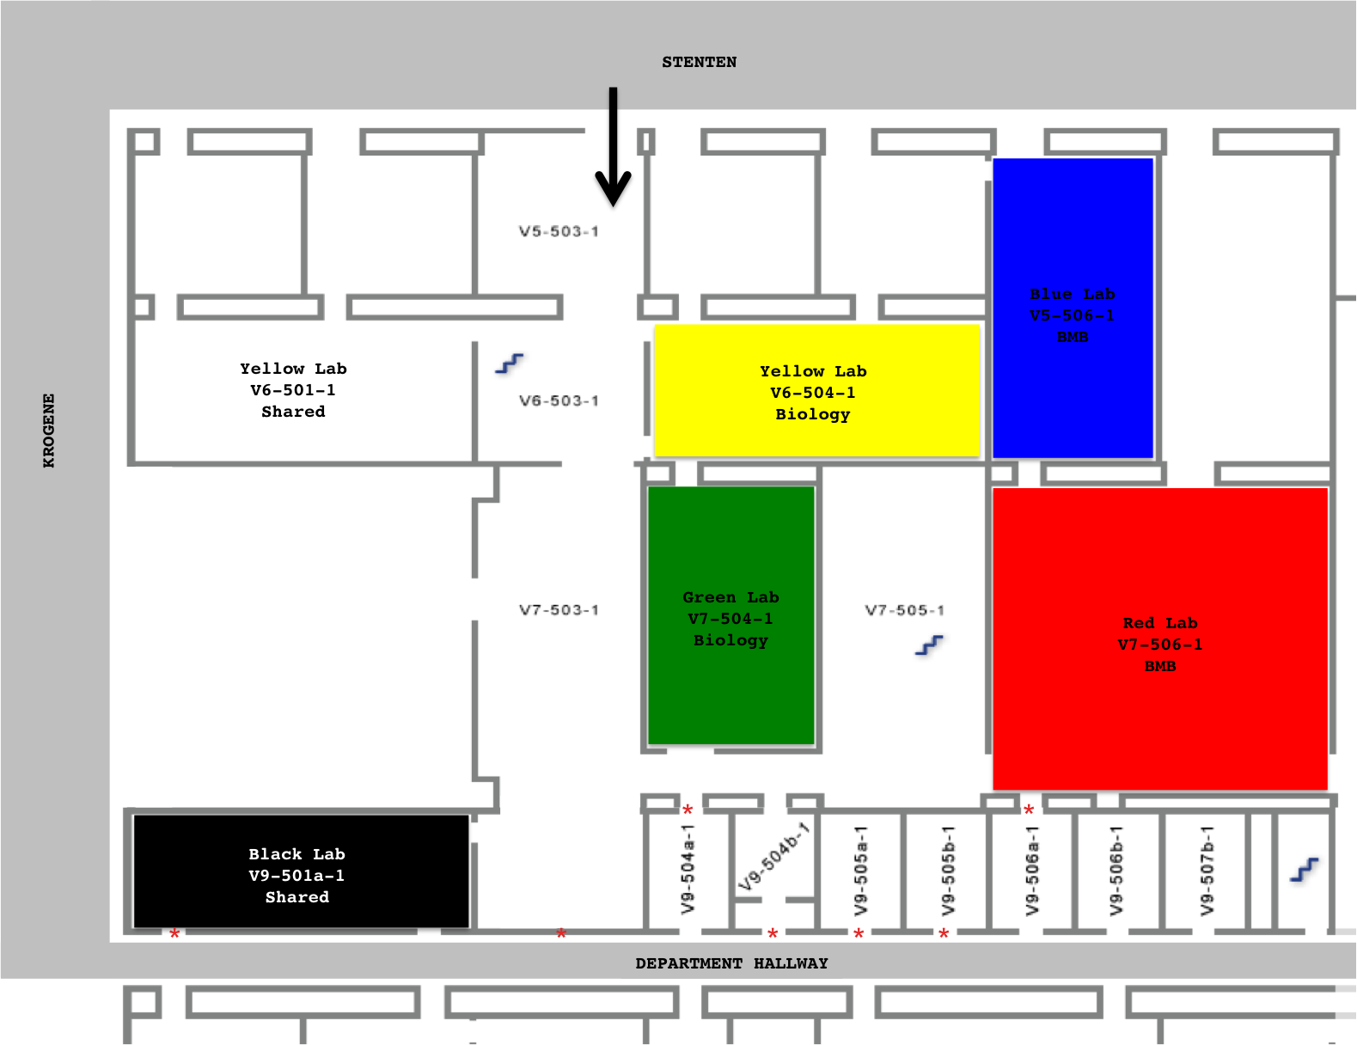

### Access to the teaching Oasis

The door facing STENTEN is open on weekdays until 3 PM. After 3 PM the students can access the Oasis using their student ID card. This means that the students can also access the department of BMB if we do not keep the doors between the Oasis and BMB locked. Therefore, when you finish teaching in the Oasis, make sure you lock the doors facing BMB.

NB. At the moment locks is not correctly installed; however, soon we will have key-locks on the inside of the Oasis, which makes it possible to access the BMB hallway from the Oasis only with a BMB/biology key.

Since automatic door-openers do not work with locks, the barrier against BMB in those cases is placed on the inner door. Stars * on the map above marks the doors to lock.

## Before you start teaching

If you plan to use the Biology teaching Oasis make sure the appropriate rooms are booked for you by Bente Frost Holbech. Also check when the next course is running so you know when to be out of the room.

You must choose a person (responsible teacher, TAP/A-TAP or instructor) who is the primary contact person. This person is responsible for all the shared equipment borrowed and used in the course and for proper cleaning of the teaching labs when the course is finished.

A list of all shared teaching equipment can be found on the Biology homepage http://sdunet.dk/Enheder/Institutter/bi/Servicefunktioner/~/media/Intranet/Public/Upload/Enheder/Institutter/Biologi/Ovelsesudstyr%20paa%20Biologisk%20Institut/Øvelsesudstyr%20BI%202013/Øvelsesudstyr%20på%20BI%202013.ashx. When the equipment is not used for teaching it is placed in the groups

If you have any technical issues or questions about controlling installations (gas, electricity, ventilation, cold room temperature) when working in the teaching labs please read the instructions found in the lab and/or on page 10. If you need technical assistance please contact the technical service by email [8888@sdu.dk](mailto:8888@sdu.dk) or in urgent matters by phone 65508888.

If you have any safety issues when working in the teaching labs please refer to the general Biology safety instructions. If you need further help please contact your own working environment representative.

### Introducing the students to the teaching facilities and safety in the lab

The teacher in charge of the lab course is responsible for instructing all students about safety in the lab. For general lab safety guidelines please refer to the safety instructions found at the homepage and the Biology emergency plan.

Make sure you specify to everybody present in the lab where the emergency exits, fire extinguishers, emergency showers, eye wash shower/bottles, and first aid kits are located and how to use personal protection wear when working in the lab.

Carefully instruct everybody how to use the equipment needed during the course. It is your responsibility that the equipment is not damaged by incorrect use!

Yellow lab is classified as a Class 1 GMO lab. For class I lab safety guidelines please refer to the safety instructions placed at the entrance to Yellow lab. If you want to work with GMO’s and you are in doubt about something please ask your working environment representative or Bente Frost Holbech well in advance before the lab course. If you are not familiar with working in a class 1 laboratory ask your working environment representative or Bente Frost Holbech for instructions. Make sure you instruct the students how to sort their waste into regular waste and GMO waste.

Black lab is classified for stabling of live animals. For more information contact Sonja Jacobsen

[sjacobsen@biology.sdu.dk](mailto:sjacobsen@biology.sdu.dk)

## When you finish teaching

You have to leave the teaching labs completely clean!

Put everything you used back in place. Remove all yellow risk waste. Wipe off all fume hoods and lab benches. Empty the fridge. Leave only hand soap and tissue paper on the bench by the sinks.

No later than one week or as soon as possible after finishing your course you have to hand back all used equipment, the cleaned lab and the calibrated pipettes. Everything has to be cleaned and placed in the correct position.

## Practical information

### Lab coats

When working with GMO in the classified labs the students are not allowed to use their private lab coats (because they cannot take them home after use in the classified area). Therefore, they should all use the lab coats placed in the teaching lab cabinet in Yellow lab.

When your course is finished, it is your responsibility to take the used lab coats for laundry. You have to bring them to the laundry facility packed in gelatin bags (max 6 lab coats per bag). When clean they will be brought back to the cabinets.

No matter if you use private lab coats or GMO lab coats, be aware that you have to leave the lab coats in the classified area. Hooks are placed by the exits from the labs. It is not allowed to wear the lab coat in the non-classified areas of the teaching facilities.

### Waste

Please refer to the Biology safety instruction on how to handle waste.

### Water

Besides regular tap water, there are two types of special clean lab-water available in the Oasis

Orange taps: Contains Reverse Osmosis water. It has a conductivity of up to 5 uS. This quality is called ASTM type 4 and is used for waterbaths.

Purelab Ultra water system, in Yellow lab: Contains water with a conductivity up to 0,1 uS. This is the best quality lab water we can produce and it is used for preparing reagents. This quality we name ASTM type 1a.

If you have any trouble using the system contact Bente.

### Pipettes

If you want to borrow pipettes from the teaching lab, please register the number and type in the pipette-book placed together with the pipettes.

Before you put back the pipettes, you have to clean and weigh out/calibrate all pipettes borrowed.

Guidelines for adjusting/calibrating Finnpipettes can be found on the frontpage of the pipette-book .

If you have any problems using or calibrating the pipettes please refer to Dina Holmgaard Skov [dinaskov@biology.sdu.dk](mailto:dinaskov@biology.sdu.dk) Who is in charge of the pipettes.

### Pipette tips

If you need sterile tips you can autoclave them at the Department ask Bente Frost Holbech if you need some help.

### Glassware

There is some storage of glassware in the teaching facilities in room V9-504b-1. If you don’t find the glassware you need, it should be brought from your own lab.

### Chemicals and reagents

Any chemicals, reagents, media, culture plates etc. used in your course have to be removed when the course is finished. There is no storage of these things (except 96% ethanol) in the Biology teaching labs. If you want to keep the chemicals and reagents for your next lab course you can make storage in your own lab area.

### Consumables

Only very few consumables are stored in the teaching labs such as e.g. gloves, pipette tips, cuvettes, and weighing boats. If you need other stuff e.g. eppendorf tubes, falcon tubes and similar things you have to bring it yourself and remove it after use. As with the chemicals, if you want to keep it for your next lab course, you can make storage in your own lab area.

### Trolleys/mobile tables

Make sure you place all trolleys/mobile tables back where you found them. The small ones belong in the Green lab, the four bench-sized ones belong in the Yellow lab. There are more trolleys placed in the black lab, which you can also use if they are not used by others.

### Balances

Make sure you leave the balances and the area around them tidy and clean!

### Water baths

Use only ASTM type 4 water in the water baths!

After use clean the water baths (jar, shaker, heater) in rodalon and if necessary scrub the heating part with a ‘rens-let’ sponge. Make sure it is dry before you place it back in the cabinet.

### iPADs

The iPADs are locked away and will be handed over by Bente Frost Holbech. When the iPads are not in use, you have to keep them locked away!

## Breakage or failure on equipment

Send an email to the workshop [frank@biology.sdu.dk](mailto:frank@biology.sdu.dk) (and cc Bente) with a description of the equipment, the failure and that the equipment belongs to the Biology teaching labs. Take the equipment to the workshop and put a note on the equipment stating:

Date

Your name and email address

Description of the equipment and the failure

That the equipment belongs to the Biology teaching lab

Send an email to Bente when the equipment is fixed. If something breaks and cannot be repaired also send an email to Bente.

## Suggestions for changes or new/more equipment

The users can make wishes for more items of existing equipment or suggestions for changes in the teaching facilities by email to Bente.

If you have wishes for new kinds of equipment, please contact Marianne Holmer.

## IT installations

See guidelines below and make sure you keep the respective contact persons orientated if you experience issues, which cannot be solved by IT-service and/or technical service immediately.

### Booking screens

If the booking screens are not showing bookings of the Oasis facilities in the actual week, please contact IT-service/science-IT via helpdesk.

The information on the info screens shows reservations made in TimeEdit. At Biology Bente is the only person who can book the teaching Oasis facilities. Contact Bente for booking.

### Info screens

If you have announcements that you would like to run on the info screens placed in the Oasis, please contact Lise Junker Nielsen, BMB.

### Computers in White lab

If you have general issues with the computers in White Lab, please contact IT-service/science IT for help. If you have issues, which are not IT-service stuff eg. if a computer is dead and cannot be fixed by IT-service, wishes for new software, or other matters, Peter Søholt is the person to contact at Biology. If IT-service needs a BMB person to discuss issues with please put them in contact with Peter Søholt.

### Smart boards

Smart boards are placed in the Green lab, Yellow lab, White room and Green theory room. There are stationary computers connected to the Smart Boards to which you can log-in using your personal Biology log-in. A brief guideline on how to use Smart Boards is placed next to the Smart Boards. If you have technical problems with the Smart Boards please contact IT-service.

When you finish teaching, remember to charge the Smart Board pens to ensure they are ready for the next user.

### Touch screen

At the entrance to the Oasis area V6-503-1, there is a touch screen intended for use by the students.

If the touch screen is used with a mac computer you need to install a driver. The Mac-driver can be found on blackboard. If there are any issues with the touch screen, please contact IT-service.

## Technical installations

### Gas supply

The instruction below is also placed at the gas-control-unit in red lab

Brugsvejledning

Inden test sikres, at alle bordhaner er lukket.

Denne laboratorietester er udviklet med henblik på at sikre, at gashanerne i klasseværelset er lukket, og at der ikke slipper gas ud af gasledningen (efter magnetventilen). Hvis der ikke slipper gas ud under testen, vil systemet give følgende visning ’aktiv gas’.

LCD-displayet giver en løbende status og tilbyder løsninger. Hvis fx et eksternt nødstop har været aktiveret, vil displayet anbefale, at nødafbryderen skal genindkobles.

Normal drift

Tjek at der er lys i den grønne spændingsindikator

Indsæt nøglen i nøgleafbryderen og drej til position ’ON’.

LCD-displayet vil vise ’VÆLG DEN ØNSKEDE FUNKTION’. De 2 funktioner kan tilsluttes og afbrydes ved hjælp af de respektive gule trykknapper.

Når trykknappen ’ELEC’ er aktiveret, vil LED-indikatorerne ovenover lyse.

Når trykknappen ’GAS’ er aktiveret, vil LED-indikatoren ovenover blinke, mens der gennemføres en test af systemet for at sikre, at ingen haner er åbne. LCD-displayet vil under testen vise en nedtælling i sekunder fra installatørens indstilling af fylde- og testtid.

Når den første funktion vælges, og hvis installatøren har indstillet autostop-timeren, vil LCD-displayet vise ’FUNKTIONER TILGÆNGELIGE I 2/4/6 ELLER 8 TIMER’ afhængig af den indstillede tid. Hvis autostop-timeren ikke er aktiveret, vil LCD-displayet vise ’FUNKTIONER TILGÆNGELIGE

Nødstop

Hvis der sker aktivering af et nødstop, vil apparatet isolere alle funktioner, og en alarmlampe vil blinke. Der vil også forekomme en lydalarm, og LCD-displayet vil vise følgende tekst: ’nødstop aktiveret (NULSTIL eksterne nødstop) NULSTIL nøgleafbryder’.

Hvis et nødstop aktiveres, og nøgleafbryder – men ingen af funktionerne – er aktiveret, vil der ikke forekomme en alarmlyd, og du vil ikke kunne bruge funktionerne, før instruktionerne på LCD-displayet er fulgt.

Fejlmeddelelser fra LCD-skærmen og LED-indikatorerne

1. ’TEST MISLYKKEDES. TJEK AT ALLE GASHANER ER LUKKET. FOR NULSTILLING TRYK 2 GANGE PÅ KNAPPEN ’GAS ON/OFF’’.

Ved denne meddelelse vil lamperne ’GAS’ og ’ALARM’ blinke, og der vil forekomme en lydalarm.

Hvis alle gashanerne er lukkede, må man tilkalde en autoriseret gasmontør.

1. ’INGEN GASTILFØRSEL. TJEK AT VENTILER ER ÅBNE. NULSTIL NØGLEAFBRYDER’.

Enten er der ingen gastilførsel til bygningen, eller en manual ’isolater??’ er lukket - eller hvis man bruger tankgas – er tanken tom.

1. ’FEJLMEDDELELSE FRA SENDERENHED. TILKALD TEKNIKER’.

Dette betyder, at der er en driftsafbrydelse i lavstrømsledningen, og man må tilkalde en tekniker.

BEMÆRK:

- Der er en blindknap nedenunder knappen ’POWER ON’ i LED-lampeområdet. Hvis ’label??’ skubbes ind over det område, kan man se gastrykket på LCD-displayet.

- Hvis den grønne lampe ikke lyser, er der ikke strøm til kontrolenheden, så de tilsluttede funktioner vil ikke være tilgængelige.

- Hvis autostop-timeren er aktiveret, vil LCD-displayet vise den tid, der er tilbage, i de sidste 30 min.

### Ventilation, fume hoods and punctual suction

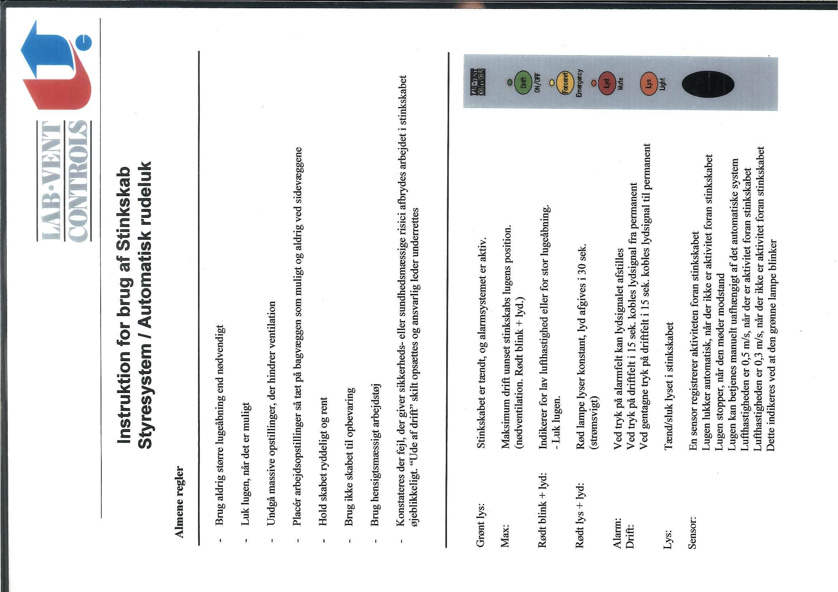The ventilation is constantly on but runs with reduced flow between 18.00 and 07.00. This means that you can leave stuff under suction over night; however, if you work in the fume hoods/suction after 18.00 or for some other reason need the fume hood/punctual suction to be on full suction, you can activate prolonged suction.

Fume hoods

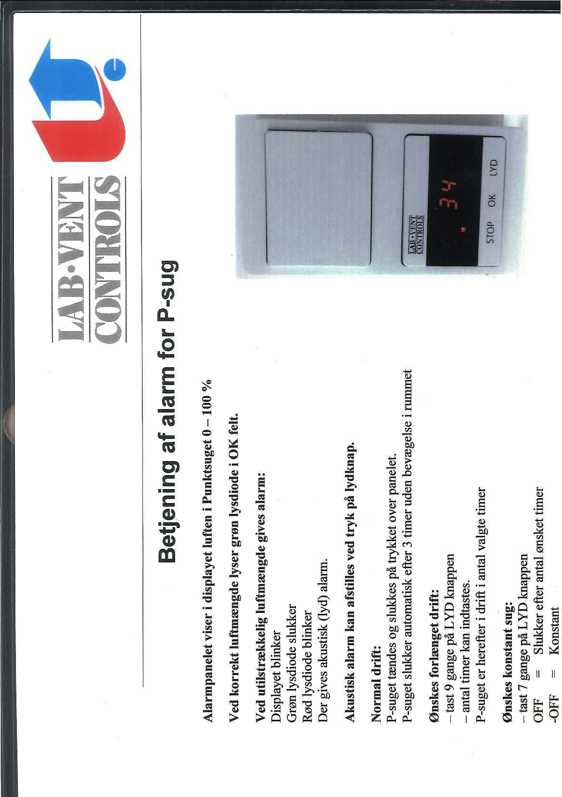

Punctual suction

### Cold room temperature

Functions on the frontpanel





## Calibration of pipettes

1. Set the pipette at the given volumes in the scheme below.
2. For each setting pipette the given volume of ASTM type 4 water into a tube/ beaker and note the weight. Repeat this minimum 5 times per volume
3. Check that the weight is within the given maximum/minimum range
4. If the weight is not within the limits use a special tool to adjust/calibrate the pipet.

Tools and guidelines for calibration can be requested from Dina.

1. Perform 5 new messurements after calibration to check whether the pipette is correctly adjusted now.
2. Repeat steps 3-6 until the pipette is correctly calibrated.

You have to adjust the pipette to be precise both in the high and low end. If not possible disassemble the pipette - clean the plunger, o-ring and/or seal and if needed change these parts. If the pipette can still not be calibrated ask Dina for help.

|  |  |  |  |  |  |  |
| --- | --- | --- | --- | --- | --- | --- |
| Pipette (µl) | Volume set | Absolute deviation (µl) | "Minimum weight" | "Maximum weight" | 5X minimum weight (g) | 5X maximum weight (g) |
| 10 | 1 | 0,025 | 0,975 | 1,025 | 0,004875 | 0,005125 |
| 10 | 5 | 0,075 | 4,925 | 5,075 | 0,024625 | 0,025375 |
| 10 | 10 | 0,1 | 9,9 | 10,1 | 0,0495 | 0,0505 |
|  |  |  |  |  |  |  |
| 20 | 2 | 0,1 | 1,9 | 2,1 | 0,0095 | 0,0105 |
| 20 | 10 | 0,1 | 9,9 | 10,1 | 0,0495 | 0,0505 |
| 20 | 20 | 0,2 | 19,8 | 20,2 | 0,099 | 0,101 |
|  |  |  |  |  |  |  |
| 100 | 20 | 0,35 | 19,65 | 20,35 | 0,09825 | 0,10175 |
| 100 | 50 | 0,4 | 49,6 | 50,4 | 0,248 | 0,252 |
| 100 | 100 | 0,8 | 99,2 | 100,8 | 0,496 | 0,504 |
|  |  |  |  |  |  |  |
| 200 | 50 | 0,5 | 49,5 | 50,5 | 0,2475 | 0,2525 |
| 200 | 100 | 0,8 | 99,2 | 100,8 | 0,496 | 0,504 |
| 200 | 200 | 1,6 | 198,4 | 201,6 | 0,992 | 1,008 |
|  |  |  |  |  |  |  |
| 1000 | 200 | 2 | 198 | 202 | 0,99 | 1,01 |
| 1000 | 500 | 4 | 496 | 504 | 2,48 | 2,52 |
| 1000 | 1000 | 8 | 992 | 1008 | 4,96 | 5,04 |
|  |  |  |  |  |  |  |
| 5000 | 1000 | 12 | 988 | 1012 | 4,94 | 5,06 |
| 5000 | 2000 | 12 | 1988 | 2012 | 9,94 | 10,06 |
| 5000 | 5000 | 30 | 4970 | 5030 | 24,85 | 25,15 |