Hollow Fiber Carbon Membranes for Separation of Hydrogen and Carbon Dioxide

Denmark is often in a situation where excess electrical power is exported due to the variation in generated wind power. This is expected to become an increasing challenge in the coming years due to expansions in renewable energy sources. This Ph.D.-work is part of a larger project with multiple partners seeking to utilize this excess power in an electrolysis process generating Hydrogen gas (H₂), which is accumulated at high pressures (70-100 bar) in a storage tank. As the need arises, the stored H₂ is utilized in a fuel cell, which converts it back into electrical energy. The safety issues associated with storing H₂ gas at high pressures can be minimized by storing it in combination with Carbon Dioxide (CO₂). However, that creates the need for a purification step both in order to reduce the amount of CO₂ entering the fuel cell and in order to minimize the need for refilling the storage system with CO₂.
In this work the feasibility of applying carbon membranes for the separation was investigated. H₂ traverses the membrane faster than CO₂ due to a molecular sieving effect, meaning it retains large molecules and allows small molecules to pass. Carbon membranes are made from polymers which are heated to 550-700 °C in an inert atmosphere or under vacuum. These materials are very brittle, which has kept them from emerging on an industrial scale so far. However, adding HCl to the pyrolysis gas has been claimed to improve the mechanical properties of the resulting carbon membranes. The validity of this claim as well as the effects on the actual gas separation performance was investigated in this work by measuring the permeabilities of H₂, CO₂, O₂ and N₂.
Hollow Fiber Carbon Membranes were prepared, since hollow fibers are the preferred configuration in industry because of a high potential packing density. The precursor polymer was cellulose acetate, which was deacetylated in order to obtain a cellulose hollow fiber suitable for carbonization. A method to generate in-situ HCl gas was developed and applied to prepare the desired pyrolysis gas-mixtures. The overall project and the functionality of a hollow carbon fiber are both illustrated below, the small H₂ molecules (blue) pass through the fiber wall while the large CO₂ molecules (red/Black) are retained.

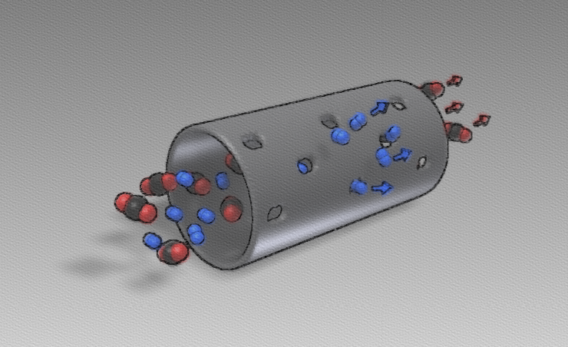
The prepared hollow carbon fibers exhibited competitive gas separation properties and the addition of HCl was confirmed to improve the mechanical strength. In addition, the HCl-gas resulted in significantly increased permeabilities for all gases, in many cases with no large impact to the H₂/CO₂-selectivity. Experiments with a mixture of H₂ and CO₂ revealed challenges with selective adsorption of CO₂. However, the addition of additives to the precursor polymer prior to pyrolysis has been shown by others to alleviate this issue.

