Attending the oral exam online
  - A guide for students

Introduction

The University of Southern Denmark use a virtual presence tool for online oral exams called Zoom.
You will be notified on Blackboard if your oral exam is conducted online.
To attend an oral exam through Zoom, please follow this guide.

Guide

How to download the Zoom client (you only have to do this once!)

- Download the Zoom client by clicking on this link https://zoom.us/test
- You will now be prompted to download the Zoom client. Follow the steps on your computer.
If you experience problems on a Mac computer, we advise you to go through the steps in this guide https://support.zoom.us/hc/en-us/articles/360016688031-Using-the-Zoom-Client-and-Zoom-Rooms-with-macOS
- Once the client is downloaded, we strongly advise you to test your video and audio ahead of the exam (preferably a few days ahead).

How to log-in with the Zoom Desktop client

- Go to https://syddanskuni.zoom.us or open your Zoom desktop client
- Log-in with SSO
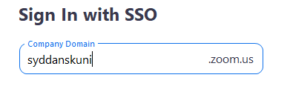
- Click Continue
- This will open your single sign-on provider in your default web browser to log in. After logging in the Zoom window should log automatically.

How to test your video and audio.

- Click on https://zoom.us/test (Please note, this link is ONLY a test link – it is NOT the link to your exam!!)
- Press Join
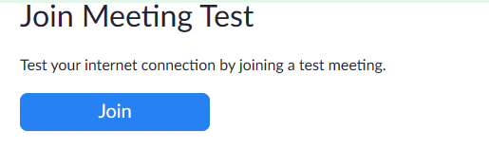
- You will now be asked to switch to the app. Press Yes.
- The test meeting will now open in your zoom app and you will be prompted to test your audio (input as well as output). Your webcam should also open by default.
- Choose Join with computer video and audio.
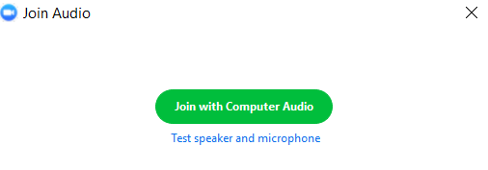
- If you are not automatically prompted to test video and audio, you can do so from within the meeting.
  - In the bottom of your screen certain options are available to you
  - By pressing on Mute you are given the possibility to change microphone and speaker and run sound checks.
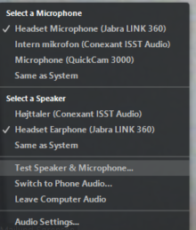

- Once you are done testing, click on Leave Meeting in the bottom right corner
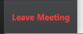

How to attend your exam online

- Your course secretary will send you a link to the Zoom exam. The link will look like this: https://syddanskuni.zoom.us/x/xxxxxxxxxxxxxxxx
- After clicking the link your exam will open in the Zoom desktop client
- If prompted, click Join, otherwise you should automatically be directed to the exam room.
- Your examiner has enabled an online waiting room. Your screen will look like this
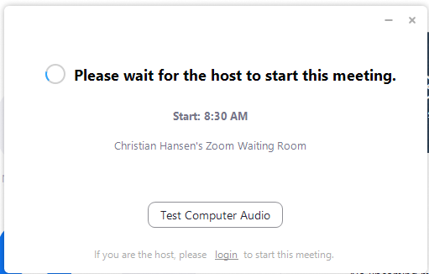
- Once your exam starts your examiner will start the meeting and you are directed to the online exam meeting.
- Upon entry your microphone might be muted. Your examiner will then tell you when you can un-mute or he/she will do it for you.

Support

Having technical problems? Contact Zoom support using updated contact information here:
https://www.sdu.dk/da/om_sdu/Fakulteterne/sundhedsvidenskab/Digital_undervisning_paa_SUND

