Lecture Title
Advancing Safety Science in Electrical Engineering

Lecture Abstract
In the realm of electrical engineering, ensuring safety is paramount to prevent hazards and ensure operational integrity. This lecture delves into the fundamental aspects of safety science within electrical engineering, focusing on key safety components and techniques such as grounding systems, fuses, circuit breakers, thermal overload relays, and ground fault circuit interrupters.
Grounding techniques provide a vital foundation for electrical systems, mitigating the risk of electric shock and equipment damage. Fuses act as indispensable safeguards by interrupting excessive current flow, thus preventing overheating and potential fires. Circuit breakers serve as dynamic protective devices, swiftly isolating faulty circuits to avert failures and enhance system reliability. Additionally, thermal overload relays play a pivotal role in controlling and monitoring electrical circuits, enhancing safety through automated responses to abnormal conditions. With an electromagnetic effect, ground fault circuit interrupters detect leakage current by monitoring the prescribed current routes. Through an exploration of these critical elements, this lecture aims to deepen understanding and promote best practices in safety science for electrical engineers, ultimately fostering safer and more resilient electrical systems. Furthermore, an outlook of system certification and applications of functional safety and cyber security will be addressed. At UL, our mission is to work for a safer world by promoting and securing safety and advancing safety science through research and investigation.

Speaker Biography
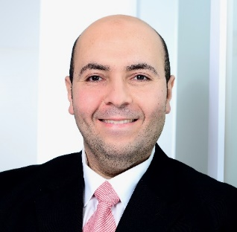
Dr. Moustafa Adly is a senior project management engineer in the Energy and Industrial Automation (EIA) segment of Underwriters Laboratories (UL). He is a senior IEEE member and Associate Editor with the Institute of Engineering and Technology (IET).
Dr. Adly received the Ph. D. degree from the Technical University of Berlin TU-Berlin in Jan. 2018, the M. Sc. degree from the German University in Cairo in Jun. 2011, and the B. Sc. degree from Cairo University in Jul. 2004. He served as a senior automotive development engineer and vice requirements manager with Volkswagen AG with a focus on the high voltage charging and body control management of electric vehicles. Formerly, he acted as a solar energy consultant with Kisun-Solar and lecturer and research scientist with TU-Berlin. Dr. Adly is passionate about renewable energy and e-mobility and is intensively contributing to the certification and standardization of power electronic systems in the photovoltaic energy and electric vehicles industries.

